


My Position Description
How I’ll succeed as…

INTERNAL SALES EXECUTIVE

MY BUSINESS & OUR MISSION
Park Fuels, is an Australian owned company that provides competitive pricing, quality products and services across the country. We deliver this with a high level of professionalism.

We value our customers and support our communities. We are environmentally responsible, safeguarding the sustainability of our operations, with a commitment to compliance and workplace health and safety.

We pride ourselves in producing a high calibre of work, whilst being flexible, innovative, adaptable and reliable.

Our P.A.R.K. values:

- Professionalism
- Action
- Respect
- Knowledge

These values are the core of our business and drive our behaviours in every business interaction, internally with each other, externally with our business partners and most importantly, with our customers.

P.A.R.K. - MY VALUES
Professionalism:
- I take pride in my work to deliver quality results and high service levels
- I am a supportive team player, approachable and collaborative, who acts with determination, motivation, integrity and reliability
- I am open, honest and trustworthy when communicating with people
- My dress and general personal presentation reflect high standards at all times

Action:
- I act with a sense of urgency and prioritise tasks to meet customer needs
- I am highly resilient and results focused
- I am pro-active and solutions orientated with a focus on business improvement
- I take ownership of issues, am accountable for my actions and prepared to take on new projects and tasks

Respect:
- I treat all people with courtesy, dignity and respect
- I protect and respect my industry environment, am responsible in my actions to safeguard the public, my team and myself
- I protect, secure and respect confidential and private information, acting in accordance with company policies, procedures and protocols
- I am considerate, caring and responsive to all customers and members of the Park family

Knowledge:
- I strive to understand our business and take time to understand how my role influences others across the business
- I keep well-informed to understand our industry, products, services and competitor activity
- I strive to enhance and develop my professional skills
- I encourage knowledge sharing and acquire new knowledge, to add value and contribute to the growth of my company
MY ROLE & MY MISSION
The Internal Sales Executive primary objectives are as follows:

- Maximise existing customers relationships into partnerships
- New account acquisition
- Achieve both the volume and margin / profitability targets
- Implement structured sales and marketing plans
- Deliver an experience that customers would describe as ‘excellent’

WHERE MY ROLE FITS INTO THE TEAM

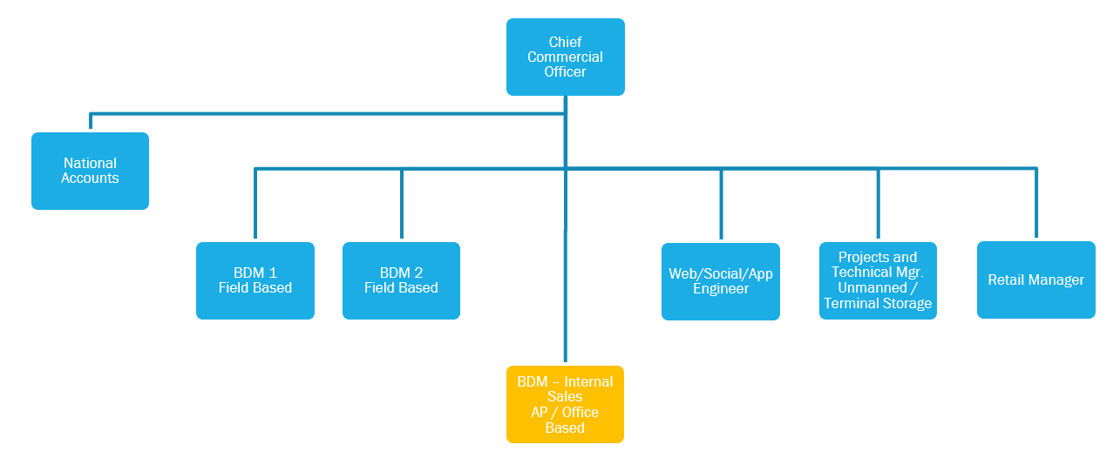

KEY COMPETENCIES
- Value driven
- Excellent communication skills
- Resilience / Self-motivated
- Fast paced / Dynamic
- Influencing / Negotiation skills
- Analytical
- Strategic thinker
- Time Management
- Self-confident
- Competitive
- Takes ownership
- Process driven
- Structured

THE SKILLS, KNOWLEDGE & EXPERIENCE – I BRING TO PARK FUELS
- Previous industry experience (desirable and not essential)
- Understanding the need for a professional and structured sales process
- Proficiency in MS Office program skills, with emphasis in Excel, PowerPoint, and Word
- Competent in using a CRM System

OTHER WAYS – I WILL MAKE A DIFFERENCE
- Support the company mission and values, keep informed about strategic partners, future ambitions and goals
- Act in the best interest of Park Fuels, at all times
- Perform any other duties that are reasonably required from time to time

HOW WILL I BE MEASURED
- Activity Management
- Sales Volume Target
- Profit Target
- New customer signings
- Customer Retention
- CRM compliance (Zoho)
- Project Management Compliance (Asana)
- Aged debt Management
- Out of terms management

MY KEY PERFORMANCE INDICATORS (KPI’s)

Frequency | Task
Daily | Daily Huddle attendance
Daily | Outbound calling - x20 calls to customer base (decision maker contact)
Daily | CRM update
Daily | Asana update
Weekly | Completion of Weekly Report
Weekly | Review aged debt / customers operating outside of terms
Monthly | 121 with CCO
Monthly | Attendance at the Commercial Monthly Meeting
Adhoc | All customers to have at least one conversation / ‘Teams’ meeting every quarter
Adhoc | Customer Agreement renewals
Adhoc | Tender Responses
Adhoc | Presentations

